
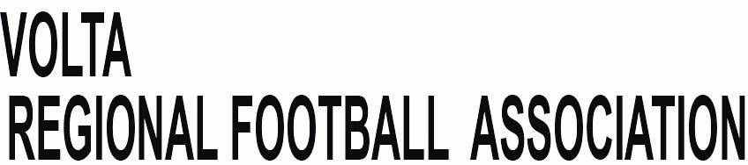

Our Ref: VFA/ADM/RSO/056/26

September 24, 2026

FOR IMMEDIATE RELEASE

VOLTA RFA SEEKS CLARITY FROM NSA ON SPECULATED 'SHATAFEST' AT HO SPORTS STADIUM; URGES PROTECTION OF PITCH

The Volta Regional Football Association (VRFA) has taken note of widespread media speculation on social media regarding an alleged upcoming event dubbed "MoMoFest/Shatafest" at the Ho Sports Stadium.

Consequently, the VRFA convened an emergency meeting with the Volta Regional Office of the National Sports Authority (NSA) on Thursday, 24th September, 2026 to seek clarification on the matter.

The meeting was attended by a section of the Executive Council of the VRFA led by its Chairman, Mr. Daniel Agbogah, Executives of Home Stars FC, and members of the media.

At the meeting, the Administrator of the National Sports Authority for the Volta Region, Ms. Jennifer Kokuma, clarified that as at the time of the meeting, the football pitch had not been rented out for any such programme.

The VRFA, however, outlined its major concerns as follows:

1. The 2025/2026 football season has commenced and some Division One League clubs are already struggling to secure a standard venue for their home matches.

2. Division One League side, Nukunu FC, has had to relocate from Akatsi to Ho to honour its home games at the Ho Sports Stadium following challenges raised by the GFA Club Licensing Board regarding the Akatsico Park.

3. Should such a non-sporting event be held on the pitch at this crucial time, the pitch will become unplayable for not less than a month, with dire consequences for our Division One League clubs.

4. In view of the above, the Ghana Football Association (GFA) may be left with no option than to direct affected Division One League clubs in the region to play their home matches in other regions, at a huge cost to the clubs and depriving Volta football fans of live football.

The Volta Regional Football Association wishes to know the commitment of the National Sports Authority to the development and promotion of football in the region and calls on the Authority to prioritize football and protect the Ho Sports Stadium pitch for its primary purpose, especially during the football season.

The VRFA wishes to assure all clubs, fans and stakeholders that it will continue to engage the relevant authorities to ensure that the interest of football in the region is protected.

END

VRFA Communications

P.O Box HP154, Ho - Ghana. Tel: +233(0)240681709, +223(0)241941341 E-mail: rfavolta@gmail.com, www.voltafa.org

